Wireframes and Test Cases

Sprint 1 AI Engine Backlog

Automated Property Valuation Model

Story 1

Wireframe
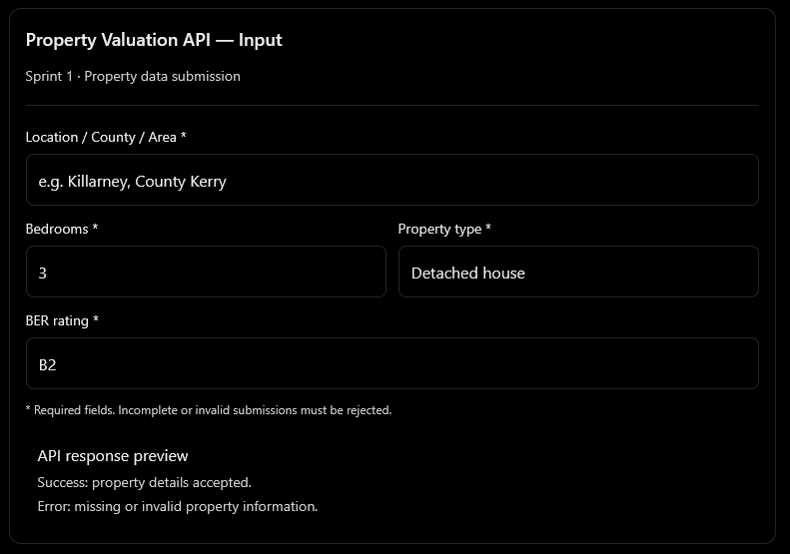

Test Cases
Test ID | Test scenario | Expected result
US1-T01 | Submit all four valid fields | API accepts the property data.
US1-T02 | Omit location, bedrooms, property type, or BER rating | Request is rejected with a validation error.
US1-T03 | Supply a negative or non-integer bedroom count | Request is rejected.
US1-T04 | Supply an unsupported property type | Request is rejected with an appropriate error.
US1-T05 | Supply an invalid BER rating | Request is rejected.
US1-T06 | Submit an empty request | Request is rejected and required fields are identified.
US1-T07 | Submit valid data using the agreed API schema | A successful response confirms acceptance of the data

Design
- Input: Location/county/area, bedrooms, property type, and BER rating.
- Validation: Check required fields, data types, permitted values, and business rules.
- Output: Structured success response or validation error.
- Interface: REST API or equivalent service endpoint.
- Dependencies: Agreed property schema and validation rules.

Story 2

Wireframe
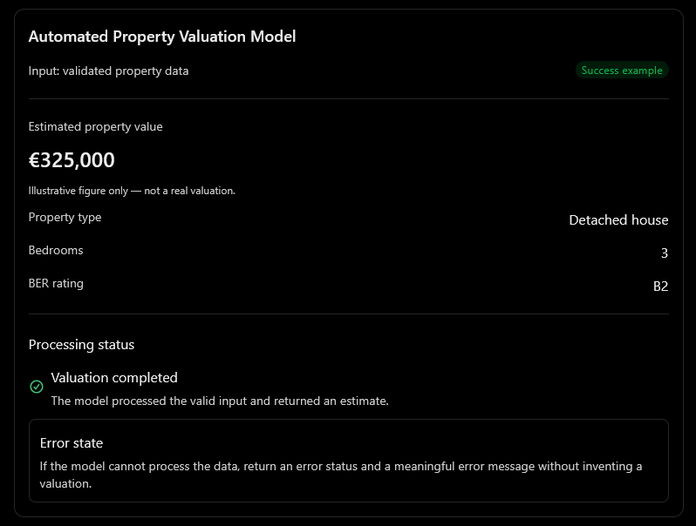

Test Cases
Test ID | Test scenario | Expected result
US2-T01 | Submit valid property information to the model | Model processes the information successfully.
US2-T02 | Submit valid inputs and the model returns a prediction | A valuation estimate is returned in the agreed response format.
US2-T03 | Model cannot process the supplied data | An error status and meaningful error message are returned.
US2-T04 | Valuation model service is unavailable | A controlled error is returned; no fabricated value is provided.
US2-T05 | Model returns an invalid or missing valuation result | The result is rejected or marked as a processing failure.
US2-T06 | Submit invalid property data directly to the model API | Invalid data is rejected in accordance with the validation contract.

Design
- Accept validated property characteristics from Story 1.
- Pass the characteristics into the valuation model.
- Generate an estimated property value using the configured model.
- Return the estimate in a defined format, including currency.
- Return meaningful errors when processing fails.
- Record the model version and relevant processing metadata where supported.

Agentic AI Architecture: Affordability Agent

Story 3

Wireframe
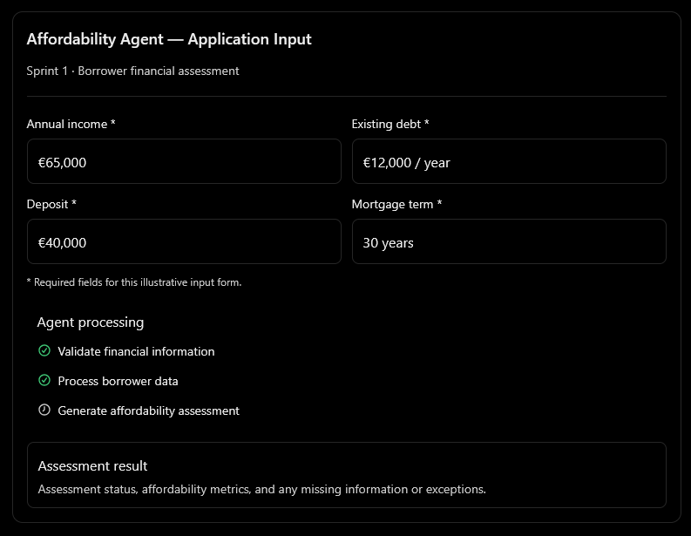

Test Cases
Test ID | Test scenario | Expected result
US3-T01 | Submit valid income, existing debt, deposit, and mortgage term | Agent accepts the application data.
US3-T02 | Submit a valid application with all required financial information | Agent produces a structured affordability assessment.
US3-T03 | Omit one or more required fields | Request is rejected or assessment is marked incomplete, according to the agreed validation contract.
US3-T04 | Submit negative income, debt, deposit, or mortgage term | Invalid values are rejected.
US3-T05 | Submit financial information in an unsupported format | Agent returns a validation error.
US3-T06 | Agent cannot complete the assessment because of a dependency failure | Agent returns a controlled error or incomplete status.
US3-T07 | Submit a valid application with high existing debt | Agent still produces the assessment; any affordability concern is reported according to configured rules.

Design
- Input: Income, existing debt, deposit, and mortgage term.
- Processing: Validate the financial information and invoke the relevant affordability calculations.
- Output: Structured affordability assessment.
- Error handling: Return validation errors or controlled processing failures.
- Auditability: Record the assessment reference, calculation results, and applicable rule versions.

Story 4

Wireframe
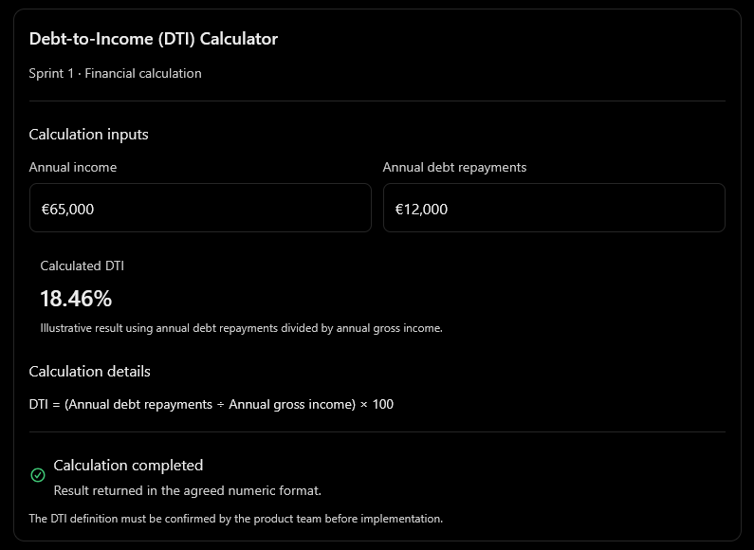

Test Cases
Test ID | Test scenario | Expected result
US4-T01 | Annual income €65,000 and annual debt repayments €12,000 | DTI is calculated as approximately 18.46%.
US4-T02 | Positive income and zero debt repayments | DTI is returned as 0%.
US4-T03 | Income is zero | Calculation is rejected or reported as undefined; no division-by-zero failure occurs.
US4-T04 | Income or debt is negative | Invalid input is rejected.
US4-T05 | Income and debt are supplied using different time periods | Inputs are normalised to the agreed common period before calculation.
US4-T06 | Required income or debt information is missing | Calculation is rejected with a clear validation error.
US4-T07 | Same valid inputs are submitted repeatedly | The same DTI value is returned using the defined rounding rules.
US4-T08 | Valid DTI calculation completes | Result is returned using the agreed response schema.

Design
The calculation for DTI shouldn’t rely on AI and calculate with this formula:
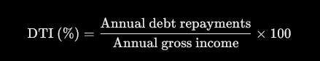

Agentic AI Architecture: Valuation Agent

Story 5

Wireframe
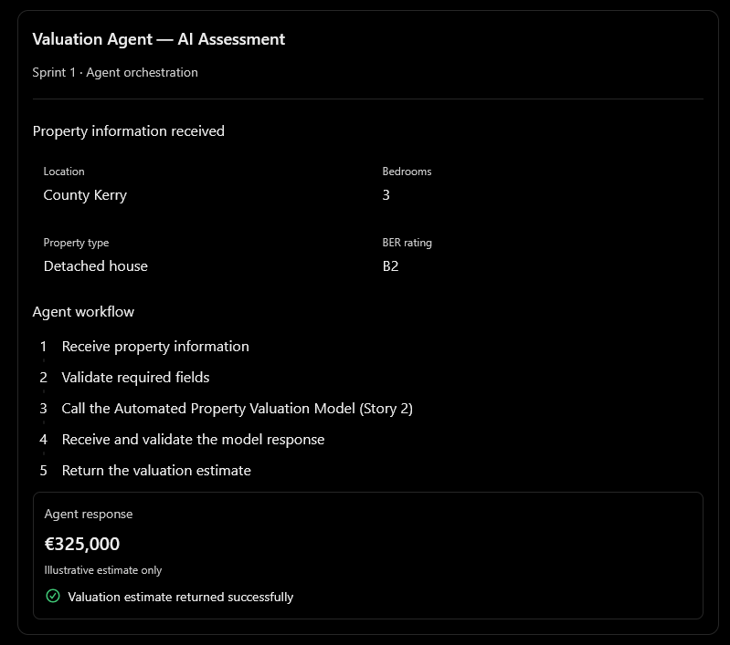

Test Cases

Test ID | Test scenario | Expected result
US5-T01 | Submit all required property information | Agent accepts the property information.
US5-T02 | Submit valid property information and the valuation model returns an estimate | Agent returns the valuation estimate.
US5-T03 | Omit a required property field | Agent rejects the request or returns a validation error.
US5-T04 | Valuation model returns a processing error | Agent returns a controlled error and does not fabricate an estimate.
US5-T05 | Valuation model returns a malformed response | Agent rejects the response and reports a processing failure.
US5-T06 | Valuation model is unavailable | Agent returns an appropriate failure or pending status.
US5-T07 | Agent successfully completes a valuation | Output includes the estimate, currency, and status in the agreed response format.

Design
- Input: The same four required property fields defined in Story 1.
- Orchestration: Validate the input and invoke the valuation model developed in Story 2.
- Output: The valuation estimate returned by the model.
- Error handling: Propagate meaningful validation and processing errors.
- Integration: Use a defined interface between the agent and valuation model.
- Controls: Validate the model's response before returning it to the consuming system.

